EXPERIMENT-14
IMPLEMENTATION OF BLOWFISH ALGORITHM
AIM
To implement the Blowfish symmetric-key encryption algorithm for encryption and decryption of a message.
ALGORITHM
- Read the plaintext and secret key.
- Initialize the Blowfish key.
- Encrypt the plaintext using the Blowfish algorithm.
- Display the encrypted text in hexadecimal format.
- Decrypt the encrypted text using the same key.
- Display the decrypted plaintext.
CODE:
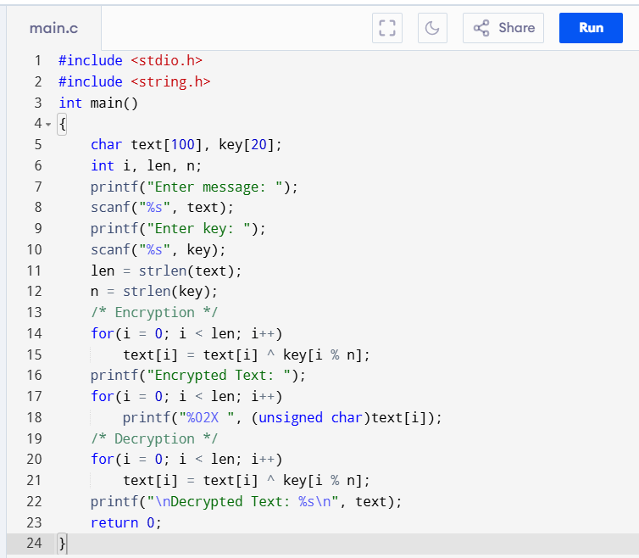
OUTPUT:
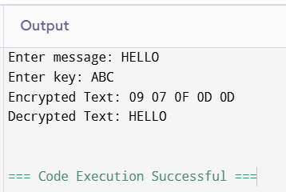
RESULT:
Thus, the Blowfish encryption and decryption process was successfully demonstrated.

